Link:https://cad.onshape.com/documents/5eeb9cfbcd42f3f52b60dd94/w/f6d7873233e4244b685fa5e2/e/a5bc83ba02c98e661c4da708?renderMode=0&uiState=69cbba4fba4ec256f3e75ad5

Lid Length: 2.134 in
Bottle Length 1.18 in
Bottle Height 3.43 in
Bottle Thickness 0.0665 in

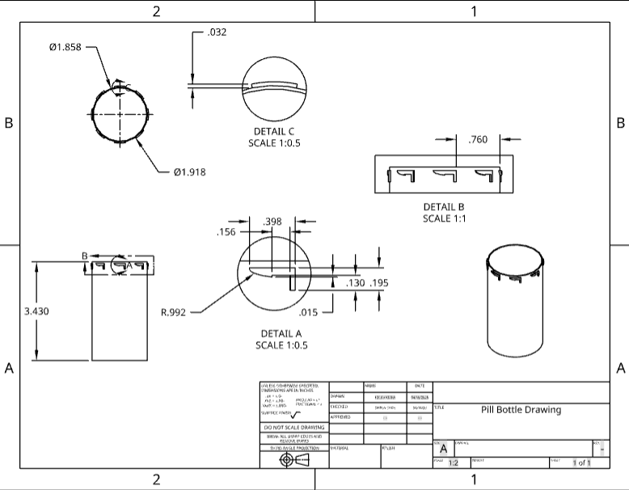
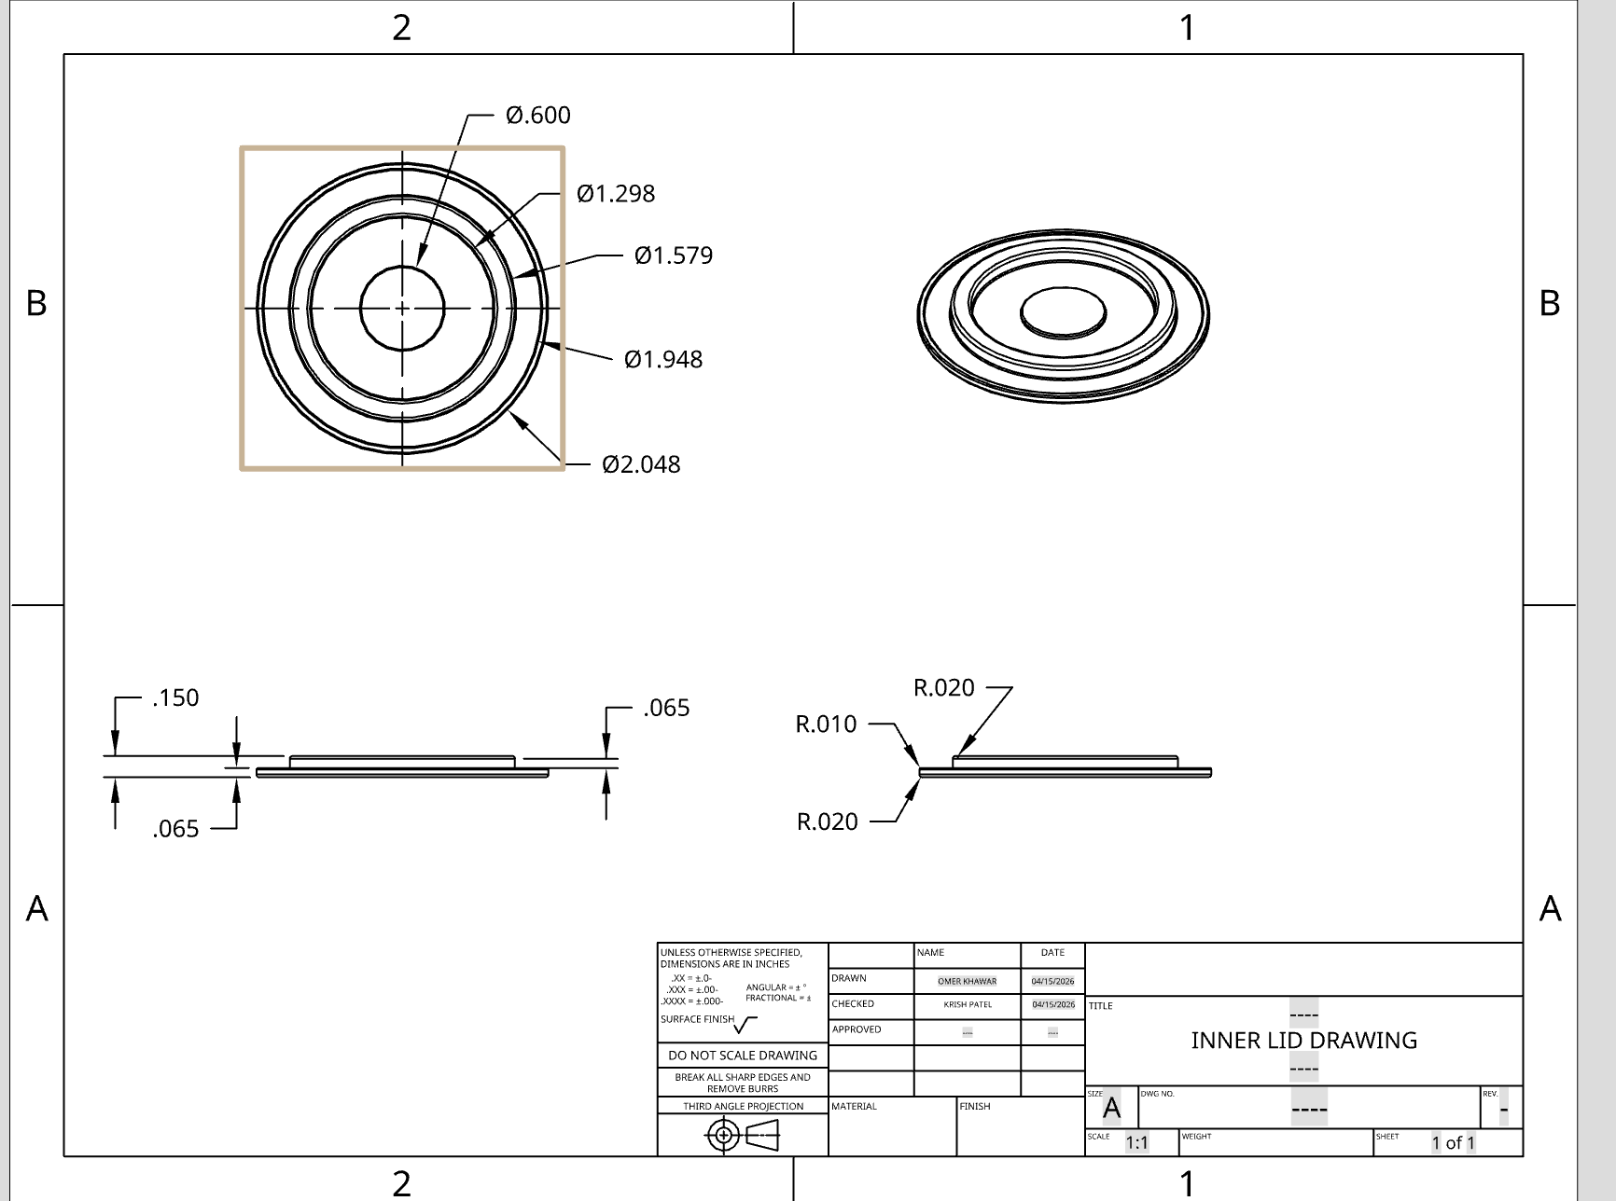

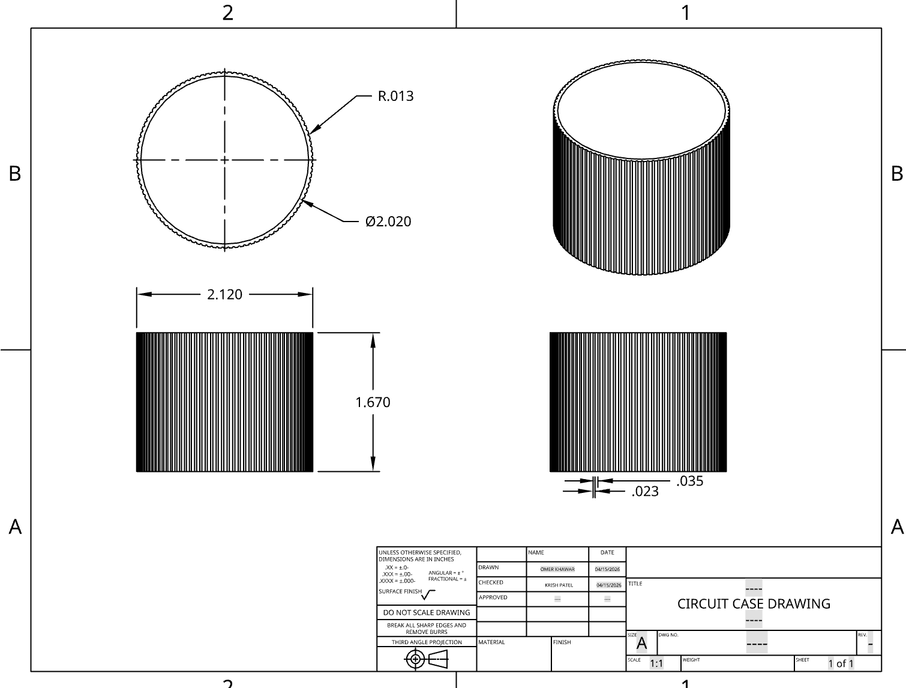

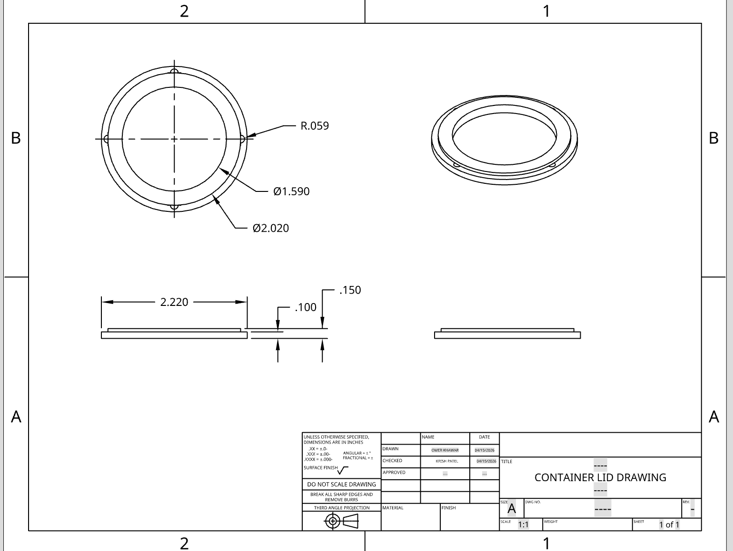

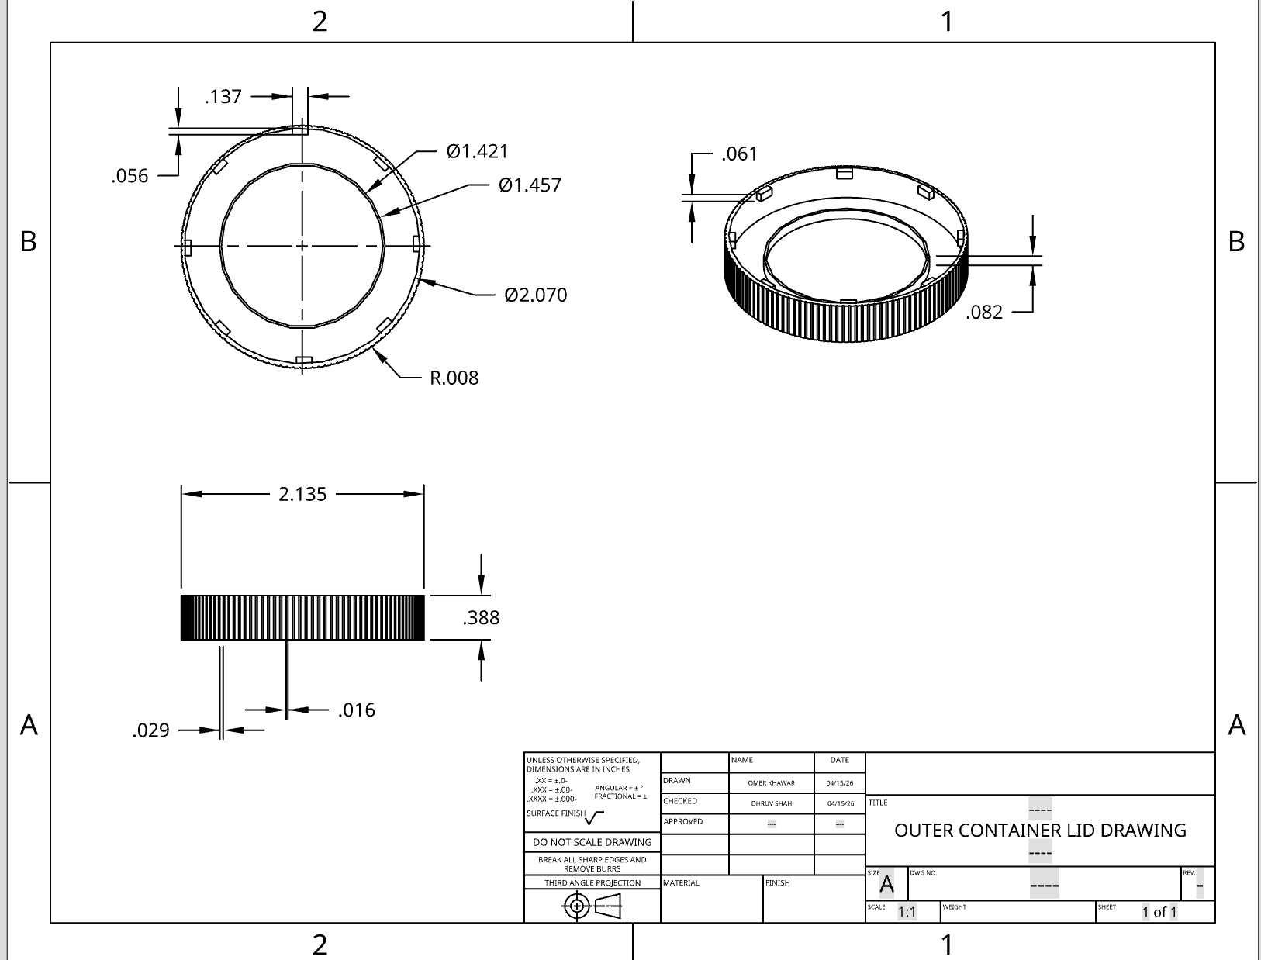

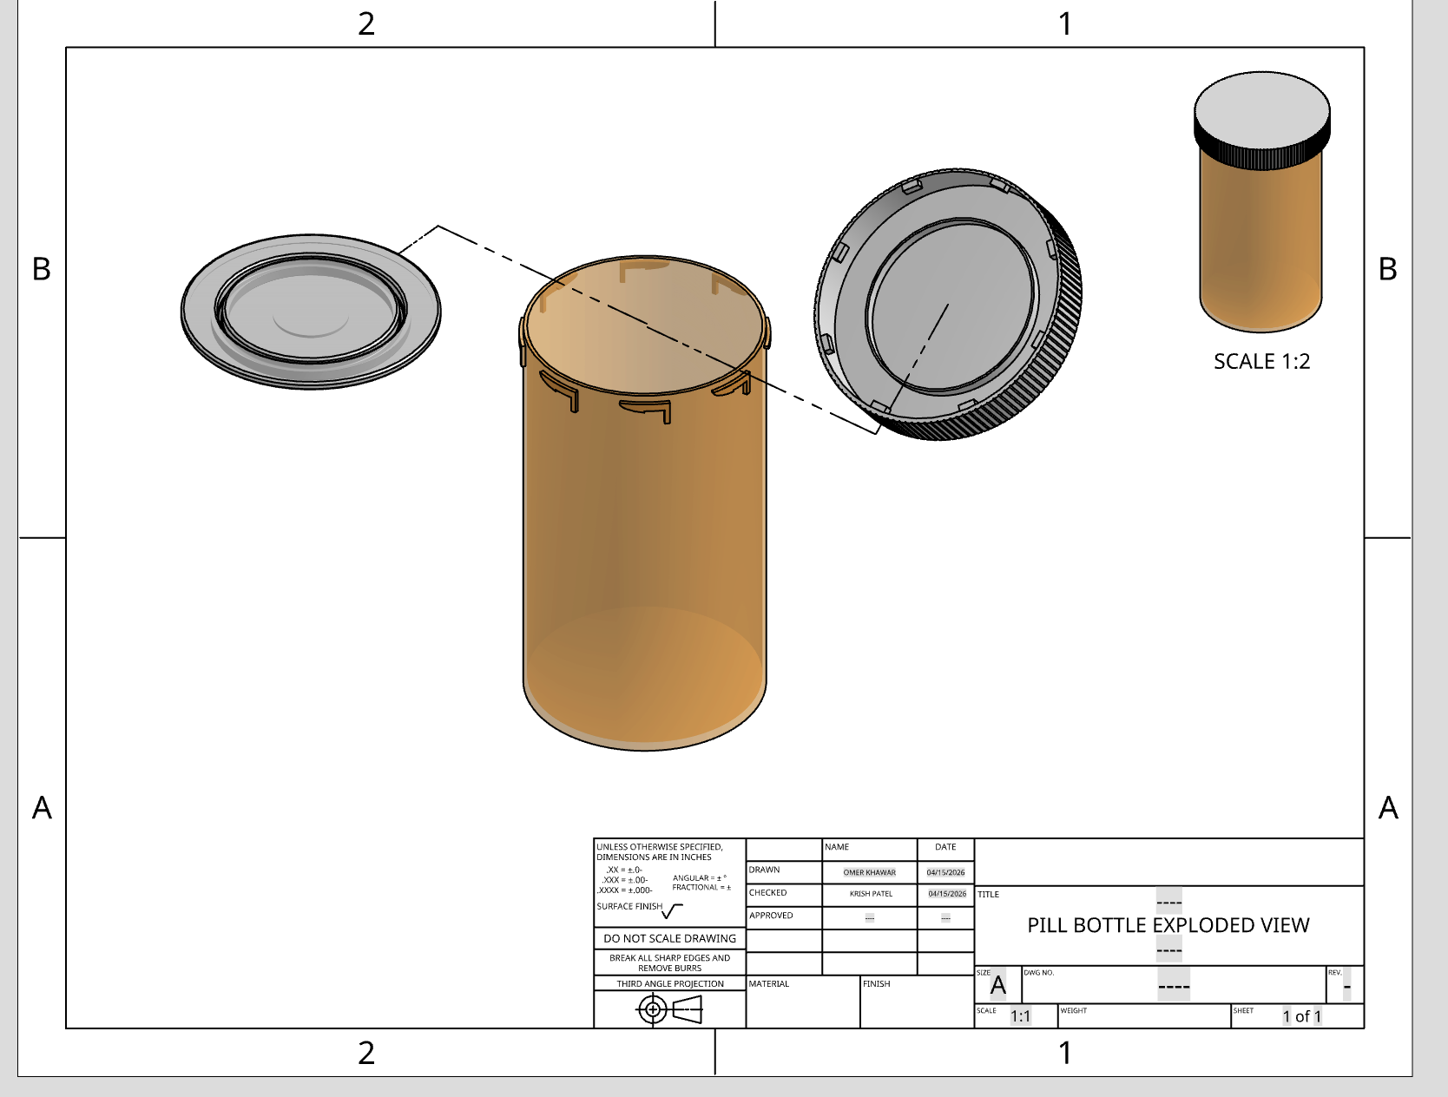

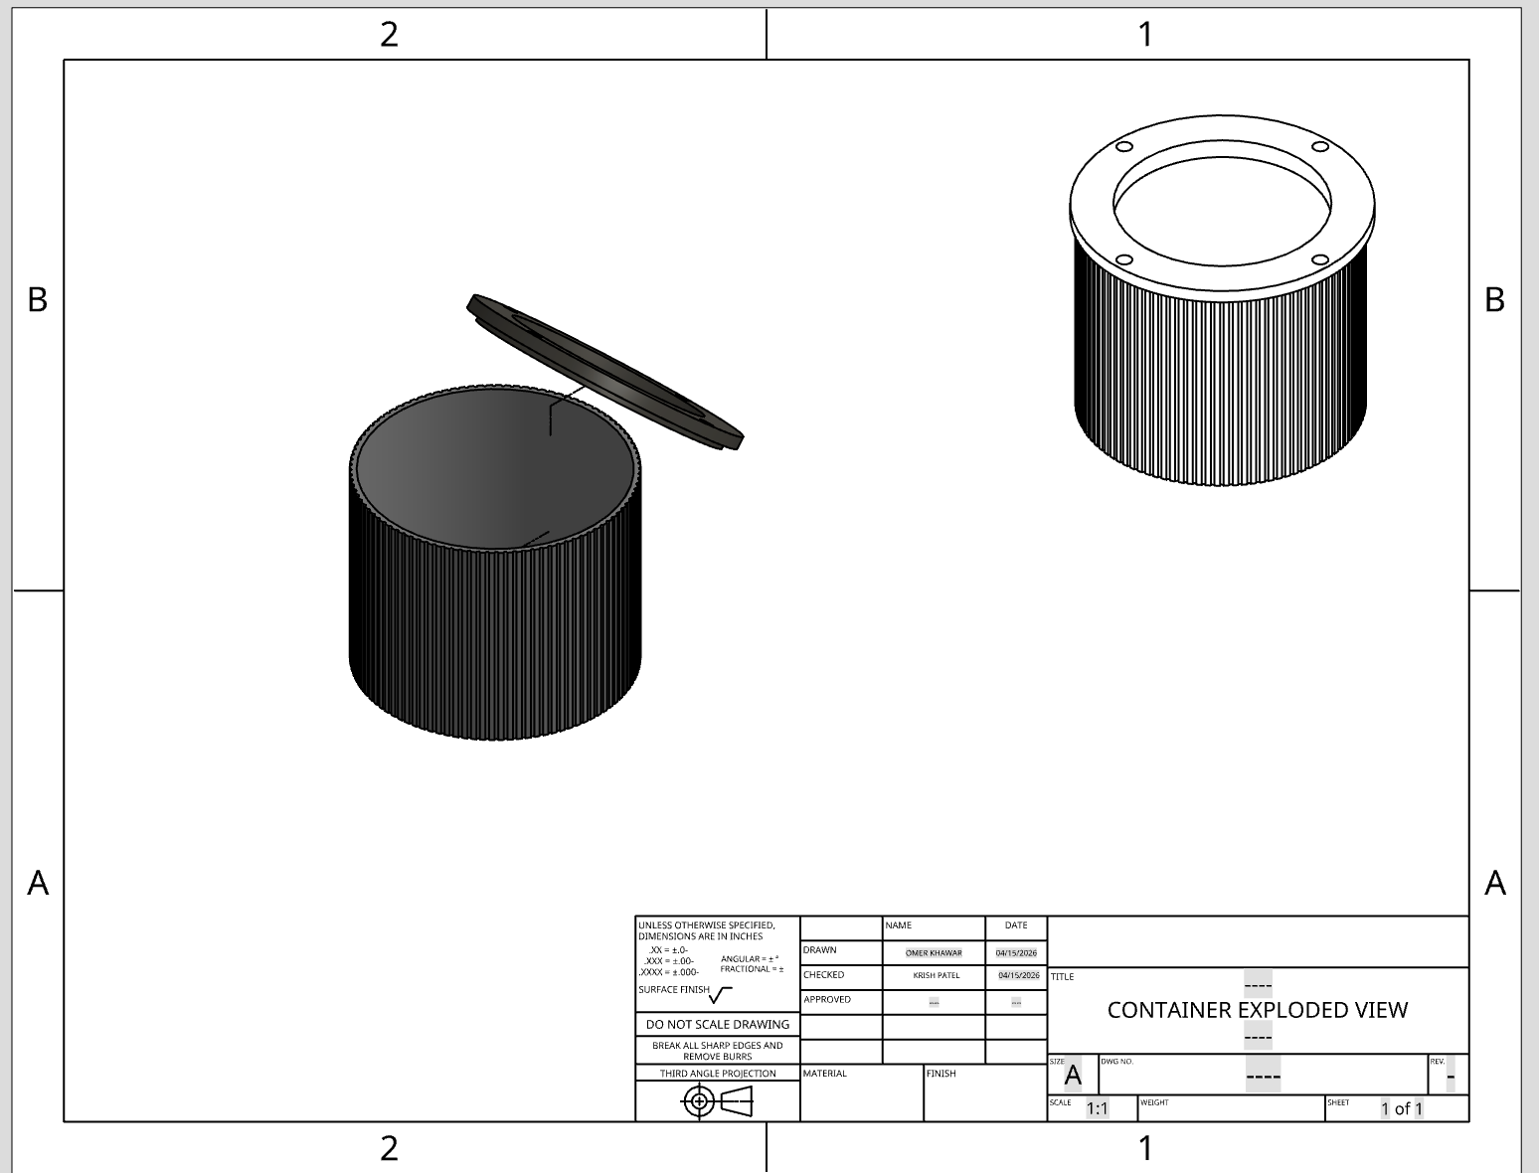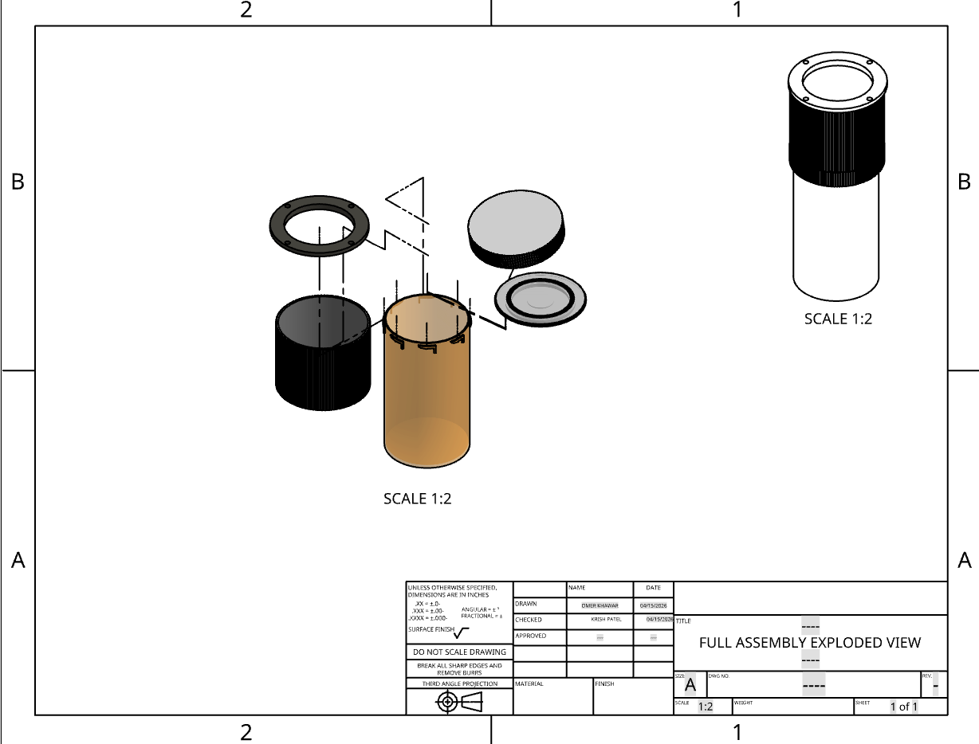

Sample Circuit:
https://www.tinkercad.com/things/6D4Uw0pELOI-dazzling-wolt-krunk/editel?returnTo=https%3A%2F%2Fwww.tinkercad.com%2Fdashboard&sharecode=1bEL5QxK2x0TGSD4Vch0nFFjvNRz9bPWU0zBpvKsOuA
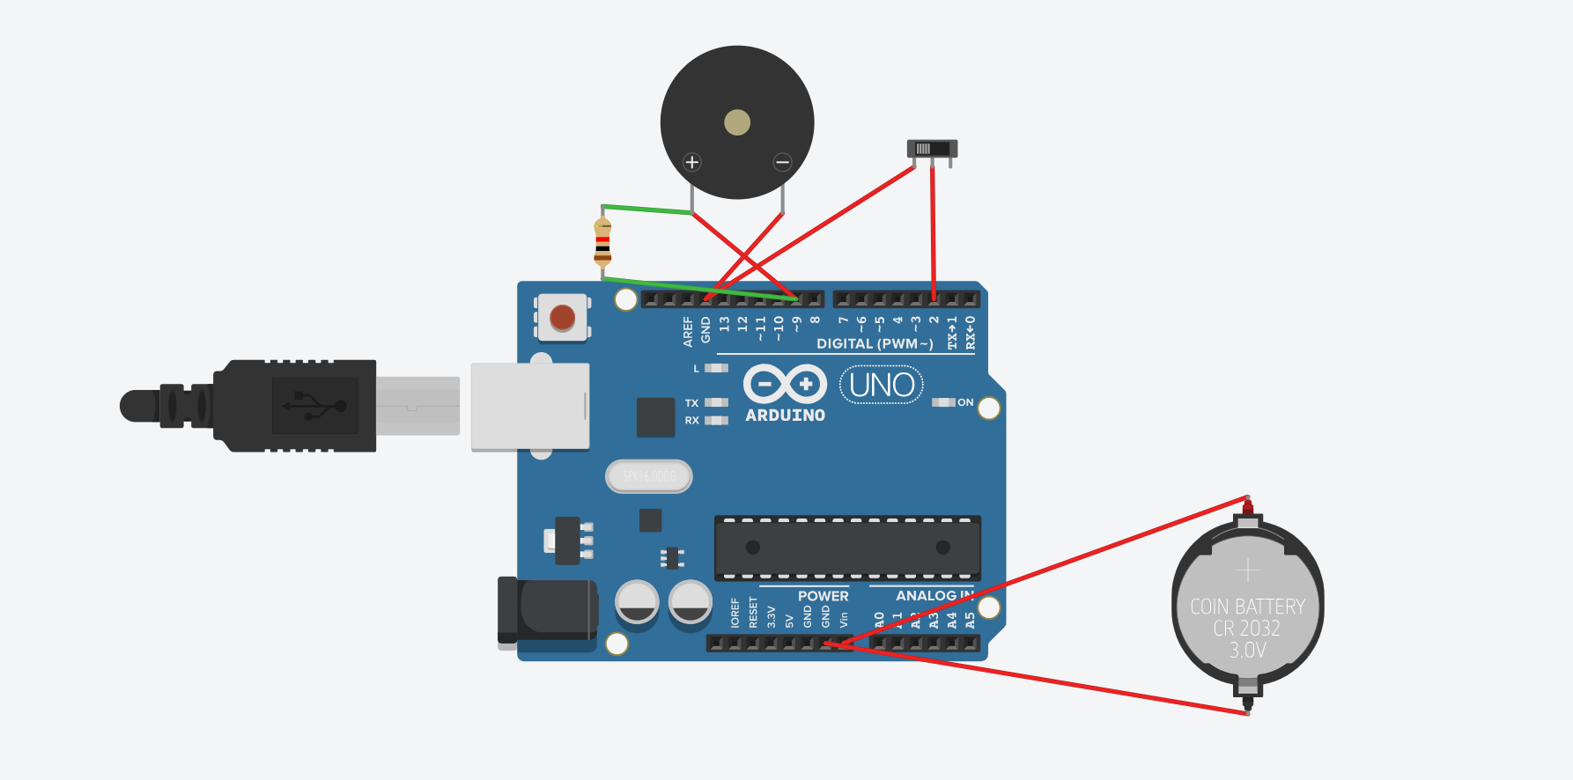

Sample Arduino Code:

int lidPin = 2; // Pin connected to the switch

void setup() {
pinMode(lidPin, INPUT_PULLUP); // Keeps pin HIGH until switch is flipped
pinMode(9, OUTPUT); // Pin for the Buzzer/Sound
}

void loop() {
// If the switch is moved (simulating lid removal)
if (digitalRead(lidPin) == LOW) {
// This "tone" represents your MP3 playing
tone(9, 880, 1000); // Play a 440Hz tone for 1 second
delay(5000); // Wait 5 seconds so it doesn't loop constantly
}
}

https://blueprint.am/s/THES1LkQDp2dgn0kr37Ucz0IB9M8jcKFRodA-dS_J-Y

